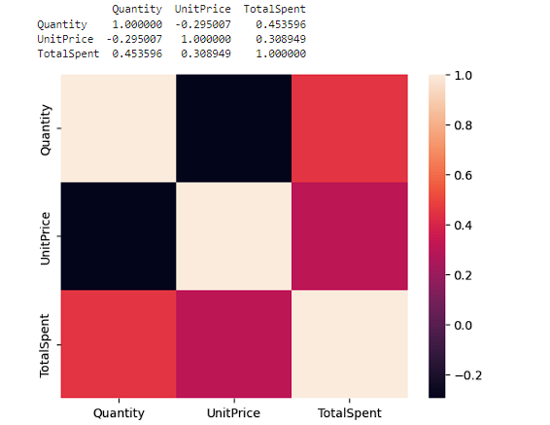

The correlation matrix above presents the correlation coefficients between the variables: Quantity, UnitPrice, and TotalSpent.

Quantity and UnitPrice:

• There exists a negative correlation of approximately -0.295 between Quantity and UnitPrice.

• This correlation implies that as the quantity of items purchased increases, the unit price tends to decrease slightly, and vice versa. However, the correlation is not very strong, indicating that the relationship between quantity and unit price is not highly linear.

Quantity and TotalSpent:

• A positive correlation of approximately 0.454 is observed between Quantity and TotalSpent.

• This correlation suggests a moderate positive relationship between the quantity of items purchased and the total amount spent. As expected, when more items are purchased (higher quantity), the total amount spent tends to increase. This relationship is reasonable and intuitive.

UnitPrice and TotalSpent:

• A positive correlation of approximately 0.309 is found between UnitPrice and TotalSpent.

• This correlation indicates a moderate positive relationship between the unit price of items and the total amount spent. As the unit price of items increases, the total amount spent also tends to increase. This relationship makes sense, as higher-priced items contribute more to the total expenditure.

In summary, the analysis reveals:

• A weak inverse relationship between quantity and unit price.

• A moderate positive relationship between quantity and total amount spent, as well as between unit price and total amount spent.